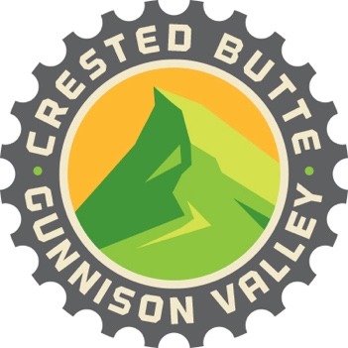

Request for Proposals (RFP) for Website Design and Maintenance for gunnisoncrestedbutte.com

June 16, 2021

Prepared by:
Gunnison-Crested Butte Tourism Association
PO Box 1069
Gunnison, CO 81230

Project Overview

The Gunnison-Crested Butte Tourism Association is seeking a vendor to overhaul the look of our website and integrate the economic development arm of our organization, gcbeconomicdevelopment.com, into our main site, gunnisoncrestedbutte.com. We are also looking to increase the visibility of sustainable tourism messaging on our site. The redesign of the site must be completed before November 1, 2021. In addition, GCBTA seeks to create a long-term partnership with the vendor for ongoing web maintenance and back-end development needs.

Project Goals

Project objectives:

The main goal of this project is to improve the user experience of our site, gunnisoncrestedbutte.com, while adhering to standards outlined in our new brand guide. Secondly, we are looking to merge content from our economic development site, gcbeconomicdevelopment.com, into our main site. Additionally, sustainable tourism content will need a larger presence on the homepage. Lastly, we are looking to improve the quality of our partner listings and partner search feature. We want to create an ongoing partnership with a vendor who not only take on this project, but also will be able to help with back-end and web development maintenance and issues as they arise in the future.

Scope of Work

- Wordpress theme constructed in a “sandbox” staging site
  - Theme mockup should include a site search feature
- Content types
  - Posts (259)
  - Pages (142)
  - Events (3567)
  - Partners (295)
  - Media
- Optimized for SEO – see this document for details
- ADA and WCAG compliant
- Optimized for mobile
- Adheres to all brand standards outlined in GCBTA brand book

Submission Requirements

Vendor should present:
- A cover letter outlining your skills and why you are interested in the project
- Project cost
- Two branded theme mockups
- Portfolio of previous work, including before-and-after comparisons
- Ongoing site maintenance and consulting agreement
  - Please specify hourly rate and turnaround time for maintenance/consulting work

Evaluation Metrics

- Adherence to brand standards and project objectives
- Adherence to best practices and accessibility requirements
- Ease of use

Inspiration

- Visitsunvalley.com
- GoBreck.com

Contact

Submission deadline for proposals is July 5, 2021. A selection will be announced on July 26.

Please submit proposals to:

Katy Mooney, GCBTA marketing manager
Mooney.tapp@gmail.com

